**WEB PORTAL FOR COLLEGE**

**ABSTRACT**

The Project **“COLLEGE WEBSITE”** is used to manage, the data of all type of specified institution/ college. Aim of developing college website is to provide an easy way not only to automate all functionalities of a college, but also to provide full functional reports to top management of college with the finest of details about any aspect of college.

This website provides the detail structure of the college campus and its departments. Website synchronizes the working of all the departments. It looks on all aspects of a college, its students, faculties, Departments, marks and other co – curricular activities.

When the development of website for an college, it makes an development of college, that every one of the world can see the system which has been followed, and the development of website, that brings very high for the college, the details include such as departments, staff, specialization, marks of internal, the programs conducted in college, exam results etc.

The project developed using the Front End Technology as JAVA and the Back End Technology as My SQL Server.

**SYSTEM SPECIFICATION**

**HARDWARE SPECFICATION**

* Processor : P 4 700 GHz.
* RAM : 4 GB RAM
* Hard Disk Drive : 180 GB

**SOFTWARE SPECIFICATION**

* Operating System : Windows 7/8/10
* Front End : JAVA
* Back End : SQL

**MODULES**

**Admin/Student Login**

Admin and student can able to login into the application. Admin can refer the admin table to login and student can be refer the student table to login into the application. After the login bellowed modules can be accessible.

**Student Registration**

A student is registered by the admin, once the admin created the student details, they have some credential to login into the application. Students details are registered by the admin and stored into the student table.

**Internal Marks Entry**

These modules only accessible to admin or teachers, student don’t have access to entering the internal marks manually. When the admin registering the internal marks student can able to check.

**Mark details view**

These modules will be visible to the both admin and student, after admin registering the marks details, they can able to view, once student can able to view their marks but admin have access to view the all the student marks.

**College details**

These details are created by the admin, admin setup all the information about the college and stored into the server. When student into the college home page they can view the all the information about the college.

**Data Flow Diagram / USE Case Diagram**

**LEVEL 0**

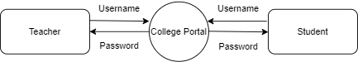

**Level 1**

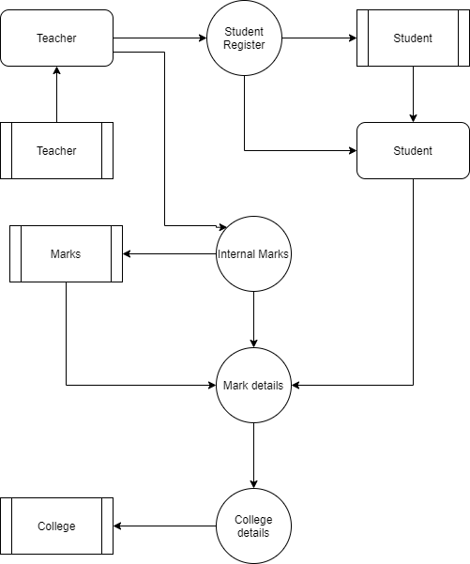

**ER Diagram**

